Answers to questions in

Lab 1: Filtering operations

Name: David Dashti Program: CMEDT

**Question 1**: Repeat this exercise with the coordinates p and q set to (5, 9), (9, 5), (17, 9),

(17, 121), (5, 1) and (125, 1) respectively. What do you observe?

Answers:

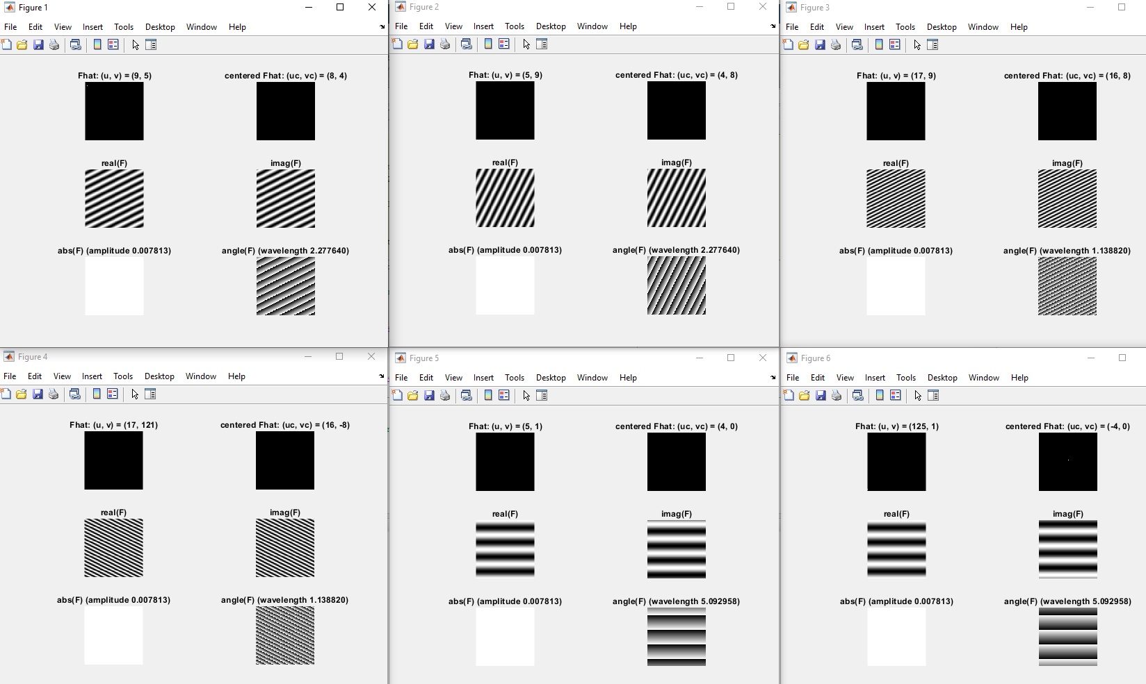

Figure - These are the plots that are generated. It goes through the points as listed in the question starting in the top left corner then going row wise to the right.

The power spectrum gets plotted of a unknow image. This image only consists of one sinewave which we get to choose the frequency of by picking p and q. This power spectrum is also centered as per convention, in the second plot. Usually, you would have a power spectrum plot with several points of varying intensity. This would give multiple spatial domain sinewaves which added together to create a full image, a so-called Fourier series. More on this later.

The imaginary and real parts of the inverse is plotted which gives us what the unknown sinewave looks like. Also, as usual, the imaginary and real sinewaves are separated by a 90° phase shift.

As the complex number can be described with Euler’s formula, the change in magnitude is plotted along with a plot where the angle changes. As expected, the magnitude of a sinewave never changes whilst going through different angles will correspond to different intensities.

The points (5, 9) and (9, 5) shows us that the change made in place of the coordinates corresponds to a 26.57° counterclockwise rotation of the imaginary and real part of the inverse. This can be best seen by adding together the vectors from the centered power spectrum. The resultant vector points in the same direction as the spatial domain sinewave.

The points (17, 9) and (17, 121) is a -53.14° rotation of the sinewave

The points (5, 1) and (125, 1) is a 180° rotation of the sinewave.

Increasing the value of the points increases the frequency of the resulting sinewave. This is because the wavelength of the spatial sinewave is inversely proportional to its frequency and dependent on a combination of u and v.

This can be described by: where

The reason why the amplitude plot is always white is because the quantization of the *showgrey* greyscale is set to the absolute value of the inverse DFT, which ironically also is the amplitude of the inverse function. Thus, the amplitude is always 1 which is the max of the greyscale as stated by the variable *Fabsmax*.

___________________________________________________________________________

**Question 2**: Explain how a position (p, q) in the Fourier domain will be projected as a sine wave in the spatial domain. Illustrate with a Matlab figure.

Answers:

The position gives the frequency component in vertical direction (corresponding to p) and the frequency component in the horizontal direction (corresponding to q). Together these will create a sinewave in the spatial domain according to the 2D inverse transform.

The formula for the inverse is the following:

Where and

The summations go from and

The spatial function is a linear combination of complex weights and complex exponentials .

The complex weight can be described as an amplitude & a phase:

&

The complex exponential has a direction and a frequency where:

&

Also notice I am assuming a N * N image, the usual notation is M * N so the term before the

summation is usually which is there to compensate for the scaling of that happens because of the sampling.

If the frequencies are far away from each other (u and v), then the resulting sinewaves wavelength, will be low. Thus, giving the resulting sinewave a high frequency. If one draws a vector from the origin of the centered plot to the point chosen, it will give the direction of the sinewave.

When doing the summations, the formula goes through *k* and *l* as stated above which in turn means that it goes through *u* and *v*. However, as it goes through these frequencies, there is only one frequency present. This frequency is the same as the frequency of the sinewave that is produced. If there would be 2 white dots, then 2 sinewaves would be present with different frequencies and so on.

I will do an example on the next page.

**Example**

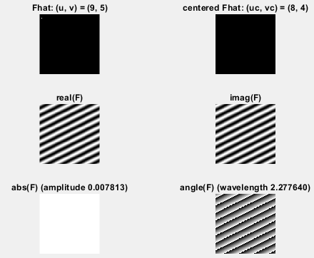Firstly, it should be mentioned that the u axis is oriented vertically, towards the bottom & the v axis I oriented horizontally, towards the right.

Figure - The Inverse DFT of a power spectrum with only the frequencies u = 9 & v = 5. The centered power spectrum is top right, the real values of the sinewave is middle left, and imaginary values middle right. Bottom left is magnitude of the sinewave as bottom right is the sinewave itself.

For the direction one must utilize the values at the centered plot as the equation is dependent on an origin of (0,0). This means that the direction of the sinewave is going to be:

The wavelength should be: 2.27764

The amplitude should be: 0.007813

The phase is:

The sinewave can thus be described by:

___________________________________________________________________________

**Question 3**: How large is the amplitude? Write down the expression derived from Equation (4) in the notes. Complement the code (variable amplitude) accordingly.

Answers:

For each time the inverse is done, it will give us a complex number whose amplitude is scaled up by a factor of the amounts of samples taken. When you inverse a 2D Fourier transform, you basically do the inverse two times, which means you need to compensate for a scaling of (sample * sample). The compensation is thus done by doing the operation of:

On top of this, the amplitude is also dependent on the magnitude of the complex weight.

This can be described by the formula:

However, thinking logically, the intensity in the point chosen is 1. And the magnitude in said point should therefore be 1. Which means

So, the amplitude *A* is: 0.007813

___________________________________________________________________________

**Question 4**: How does the direction and length of the sine wave depend on p and q? Write down the explicit expression that can be found in the lecture notes. Complement the code (variable wavelength) accordingly.

Answers:

p refers to the frequency of a sinewave going vertically, and q refers to a sinewave going horizontally. In the 2D inverse, these two frequencies add together to create a new frequency, the frequency of the resulting spatial domain sinewave.

Going from the origin of the centered power spectrum to the point given will give you the direction of the wave front created by the sinewave.

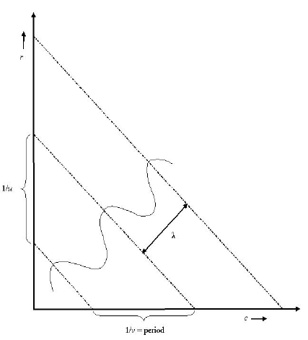

Figure - The interplay of the frequencies r = u & c = v. Together they create a wave front with the wavelength & the direction .

As stated earlier, the complex exponential has a direction and a frequency where:

& ,

The complex exponential can be described as:

Where: and the unit vector along

And: is a vector along in the spatial domain

If you take the inner product of & *,* then you get the projection onto *.* Now, all points on a line perpendicular to have the same projection.

Thus: represents the wave front.

How the wave front behaves is described in figure 2.

___________________________________________________________________________

**Question 5**: What happens when we pass the point in the center and either p or q exceeds half the image size? Explain and illustrate graphically with Matlab!

Answers:

It is basically a centering of the frequencies in the power spectrum, so you get high negative frequencies in the top for *u* and high negative frequencies at the left for *v*. In the middle you have the centration. It is done so periodicity is still intact with going from negative pi to positive pi, instead of zero to two pi.

The reason behind this is that the frequencies can then be described through Euler’s formula which is the basis for the both the Fourier Transform and the Inverse Fourier Transform.



Figure - This is how the centering is done. The left image goes from 0 to 2  
-

___________________________________________________________________________

**Question 6**: What is the purpose of the instructions following the question *What is done by these instructions?* in the code?

Answers:   
  
To understand the range of the frequencies in the power spectrum and how they got from negative half to center to positive half. This is the typical way of illustrating the power spectrum and it allows for low frequencies to be illustrated as a “bubble in the middle” with higher frequencies in the outskirts. Also, the frequencies can be described by Euler’s formulas, as stated above.

___________________________________________________________________________

**Question 7**: Why are these Fourier spectra concentrated to the borders of the images? Can you give a mathematical interpretation? Hint: think of the frequencies in the source image and consider the resulting image as a Fourier transform applied to a 2D function. It might be easier to analyze each dimension separately!

Answers:

When taking the Fourier Transform of a box function in a dimension, one will get with a sinc function that changes in the orthogonal direction of the box function.

The Fourier transform is done for each column, then each row, in a 2D spatial Fourier transform. Going from top to bottom then left to right. That means for the first pass, the first pixel in each column, the frequency is going to be zero which makes the transform a summation of the intensities in all the pixels associated with that column. And on the second pass, the same happens with the rows, thus making the functions values very high in the edges.

Worth mentioning is that the transform is separable This means that you can either start with the rows or the column and end up with the same result.

___________________________________________________________________________

**Question 8**: Why is the logarithm function applied?

Answers:

The dynamic range in the sinc function is quite high and to compensate for this the logarithm function is used.

Because the higher frequencies decrease in intensity quite rapidly, a logarithmic function helps display these higher frequencies. They would otherwise be shown as “pure black”, due to the high dynamic range. One could say it compresses the dynamic range to better account for the number of greyscale levels. This can be seen in figure 5.

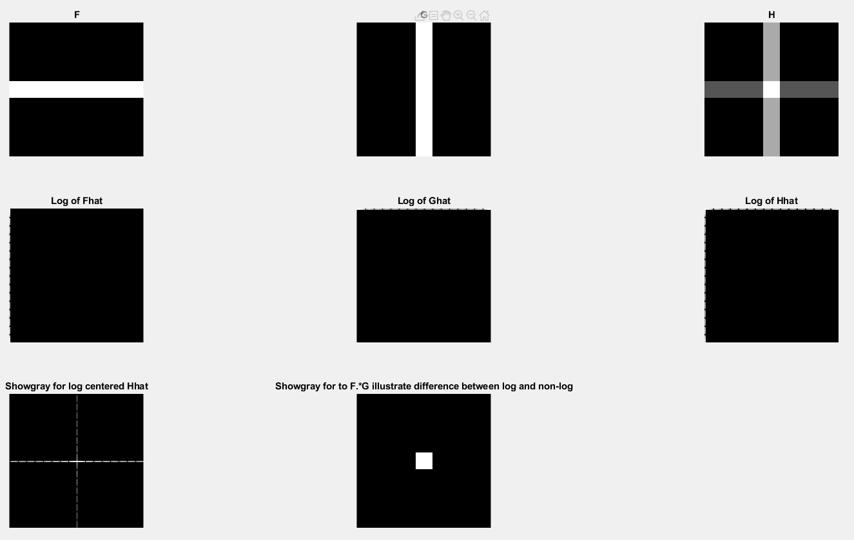

Figure - The first row shows the linearity of Fourier Transforms and the two bottom rows shows how the logarithmic function helps with the visualization of the sinc function. Especially the bottom row.

___________________________________________________________________________

**Question 9**: What conclusions can be drawn regarding linearity? From your observations can you derive a mathematical expression in the general case.

Answers:

We can tell that the Fourier Transform is a linear transform and has the following behavior.

If: is a combination of two spatial domain images

Then: is a combination of the frequency spectrum of those images

This is illustrated by the top row of Figure 4.

___________________________________________________________________________

**Question 10**: Are there any other ways to compute the last image? Remember what multiplication in Fourier domain equals to in the spatial domain! Perform these alternative computations in practice.

Answers:

The 2D convolution theorem states the following:

However, the reverse also works:

Thus, we can do a convolution of the Fourier transforms to get the same result.

This is visualized in Figure 5.

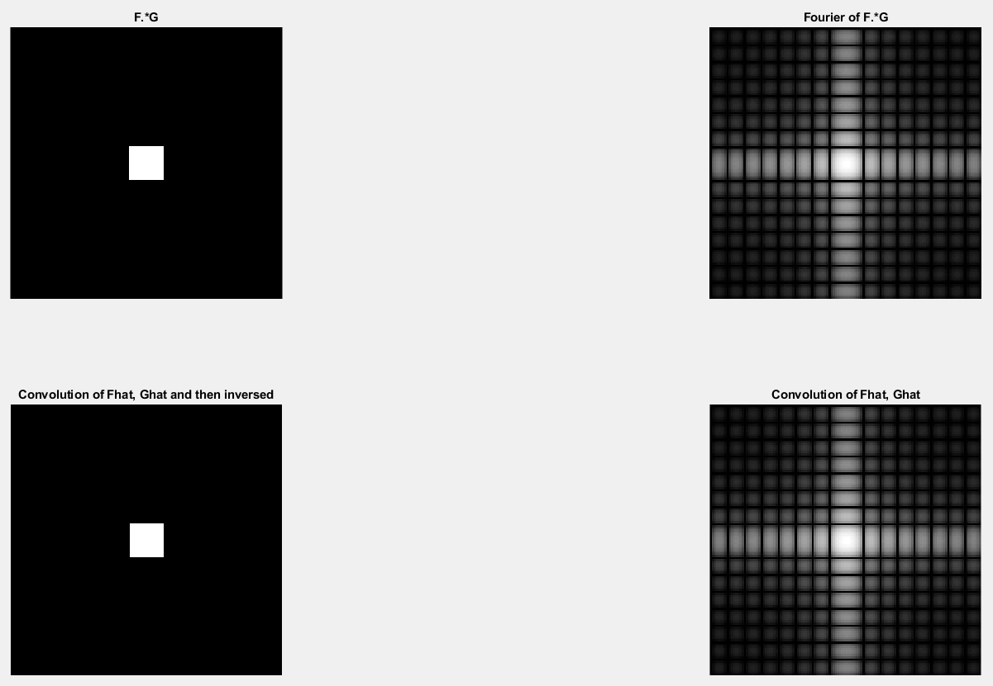

Figure - The top row shows what the matrix multiplication looks like and its Fourier Transform and the bottom row shows how you can wander between the two using the convolution theorem and still get the same results. The right column is connected, and the left column is connected.

___________________________________________________________________________

**Question 11**: What conclusions can be drawn from comparing the results with those in the previous exercise? See how the source images have changed and analyze the effects of scaling.

Answers:

The scaling in each direction will affect the oscillation frequency of the sinc functions.

The function is described by: F(u) =

Where: *W* is the length of the box function and *A* is its amplitude.

If you make the block thicker in one direction will make the oscillation frequency bigger in the perpendicular direction. And vice versa.

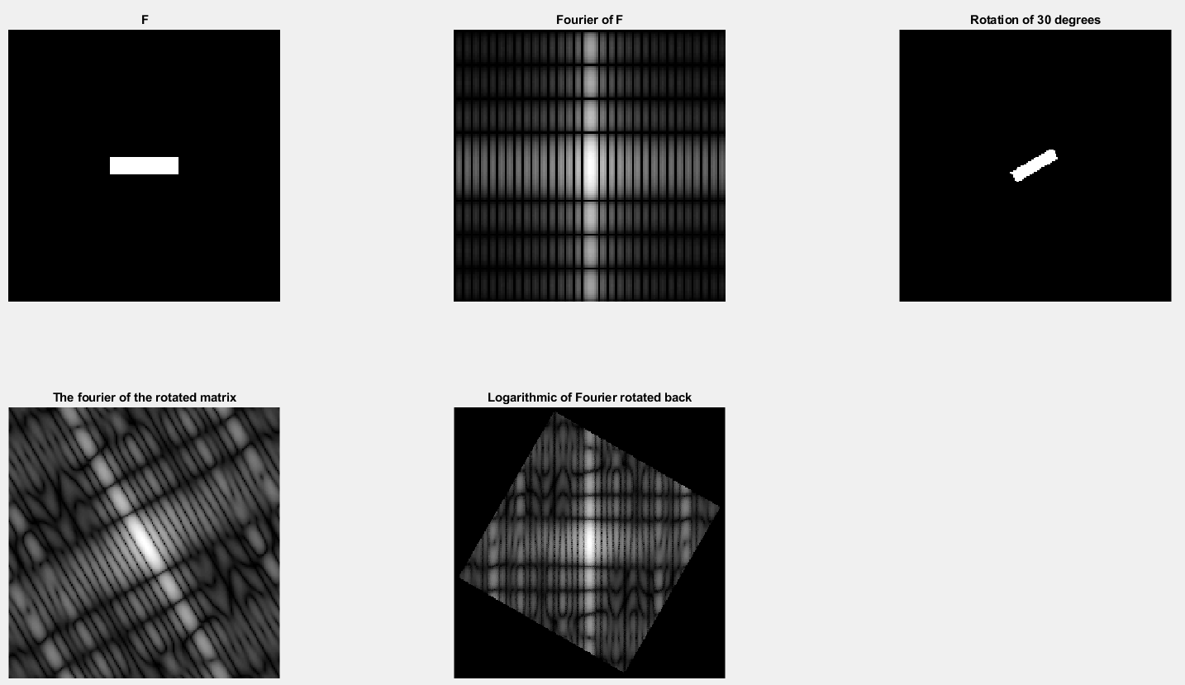

Figure - Shows how the rotation interplay works

_____________________________________________________________________

**Question 12**: What can be said about possible similarities and differences? Hint: think of the frequencies and how they are affected by the rotation.

Answers:

Rotation of an image in the spatial domain, will correspond to the same angle of rotation in the Fourier domain.

This is illustrated in Figure 6.

Also, when rotating images in the spatial domain, one will see effect on its edges. They become more “speckled”. This creates artefacts in the Fourier domain. However, this is not the case if the rotation is of where *n* is an integer.

The rotation can be described by the following:

___________________________________________________________________________

**Question 13**: What information is contained in the phase and in the magnitude of the Fourier transform?

Answers:

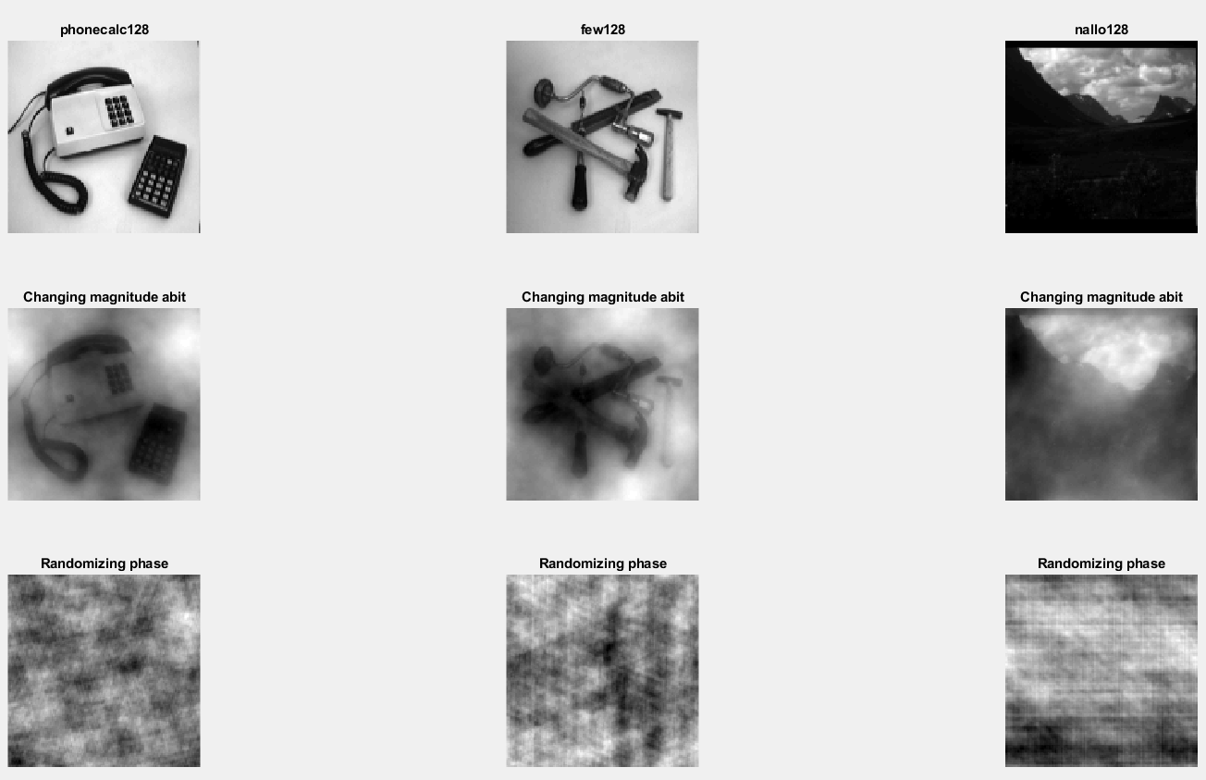

Figure - Three images with two operations done to each. In the top row you can see the images unaltered. In the middle row you can see the images magnitude nudged. In the bottom row you can see the images with randomized phase. Each column images belongs to each other. All images are in spatial domain.

The magnitude carries information about the intensities found in the image whilst the phase carries information of where the contours of objects are supposed to be.

With a randomized phase one cannot tell at all where the objects are supposed to be even though the intensity spectrum seems to be intact. When the magnitudes are nudged a bit, one can easily distinguish the objects, but they are a bit blurred due to intensity changes.

___________________________________________________________________________

**Question 14**: Show the impulse response and variance for the above-mentioned t-values. What are the variances of your discretized Gaussian kernel for t = 0.1, 0.3, 1.0, 10.0 and 100.0?

Answers:

These are the matrixes for the variances going from to

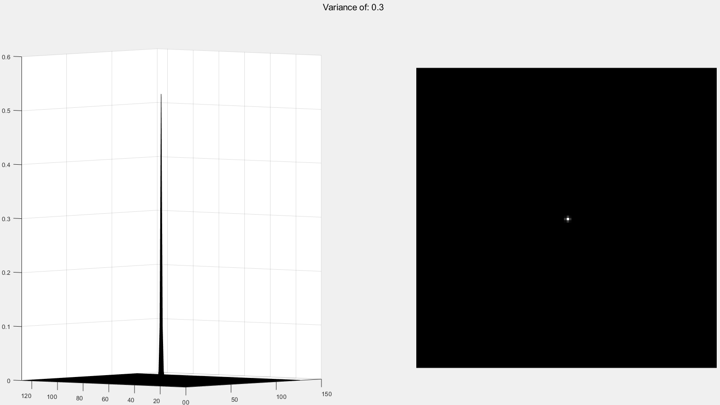

Figure - Impulse response of Gaussian Filter with variance 0.3

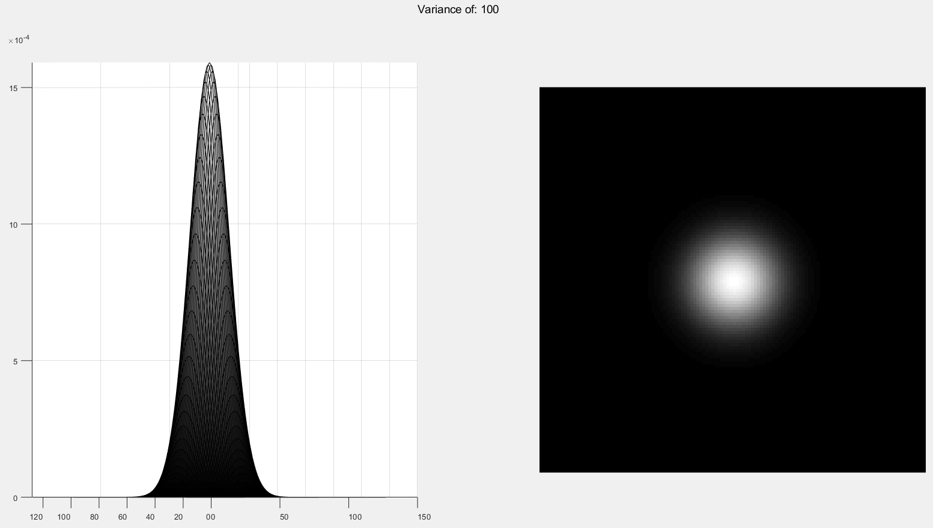

Figure - Impulse response of Gaussian Filter with variance 100

___________________________________________________________________________

**Question 15**: Are the results different from or similar to the estimated variance? How does the result correspond to the ideal continuous case? Lead: think of the relation between spatial and Fourier domains for different values of t.

Answers:

The gaussian filter is described by the following formula:

,

The gaussian filter makes the image blurrier with increased values of variance *t*. This is because the Fourier Transform of a gaussian gives a gaussian whose variance become inverted, thus filtering out higher frequencies.

Also, if the variance is under 1 then the filter in Fourier Domain becomes very broad which allows for all the frequencies to be displayed and forms almost delta pulse.

___________________________________________________________________________

**Question 16**: Convolve a couple of images with Gaussian functions of different variances (like t = 1.0, 4.0, 16.0, 64.0 and 256.0) and present your results. What effects can you observe?

Answers:

Kind of what is said in 15. The higher the variance, the more of the steep gradient changes gets smoothened.

___________________________________________________________________________

**Question 17**: What are the positive and negative effects for each type of filter? Describe what you observe and name the effects that you recognize. How do the results depend on the filter parameters? Illustrate with Matlab figure(s).

Answers:

Out of all the filter, I consider the median filter to be the best one for this job.

The gaussian filter does a great job at smoothing the image but at higher variances, it includes the salt and pepper noise into the image. Thus, integrating the noise into the image. The gaussian filter also handles add better than sap which has to do with the add noise being gaussian.

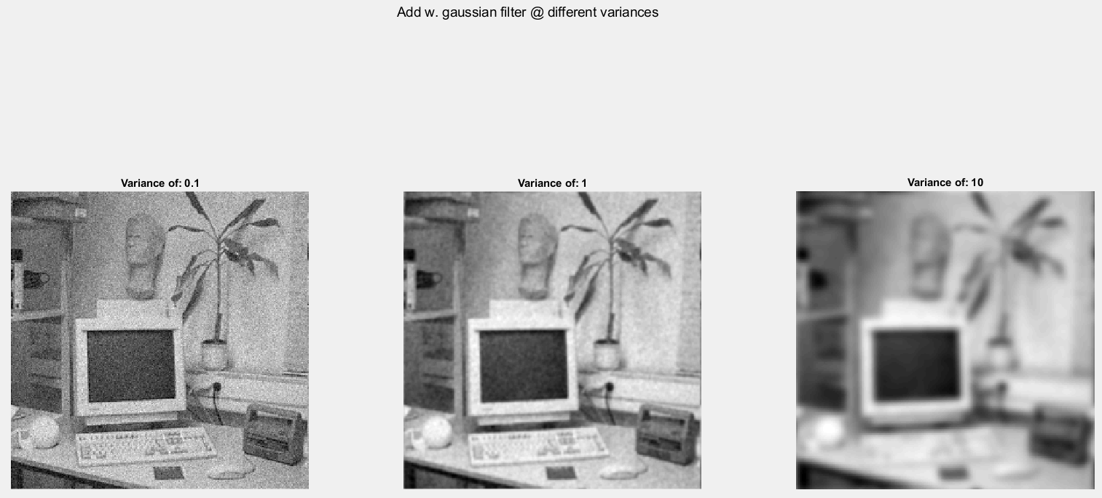

Figure - Gaussian noise with Gaussian Filter

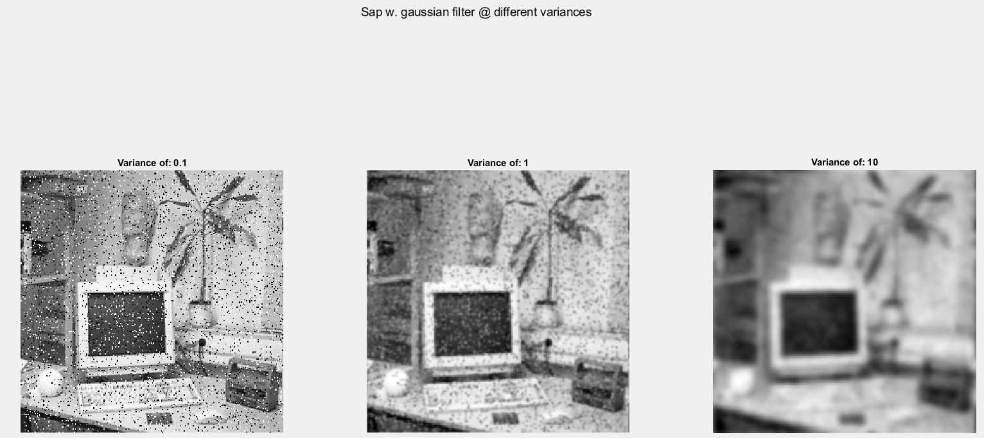

Figure - Salt and Pepper noise with Gaussian Filter

The median filter eliminates the heavy salt and pepper noise by removing the extreme values. However, it does smoothen the images a lot when reaching higher window sizes. The images become almost painting like. Also, the borders of the image become black when the window size is high enough, probably due to zero padding.

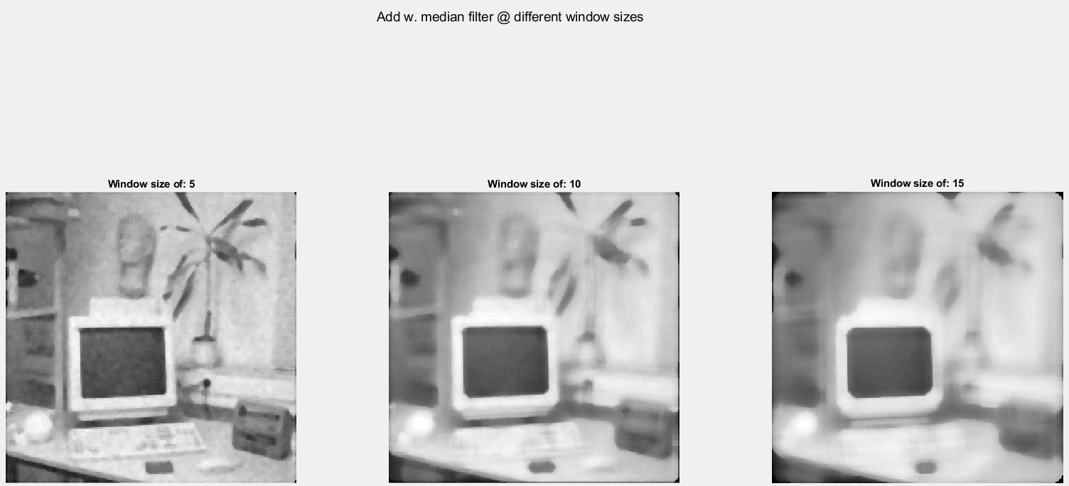

Figure - Gaussian noise with Median Filter

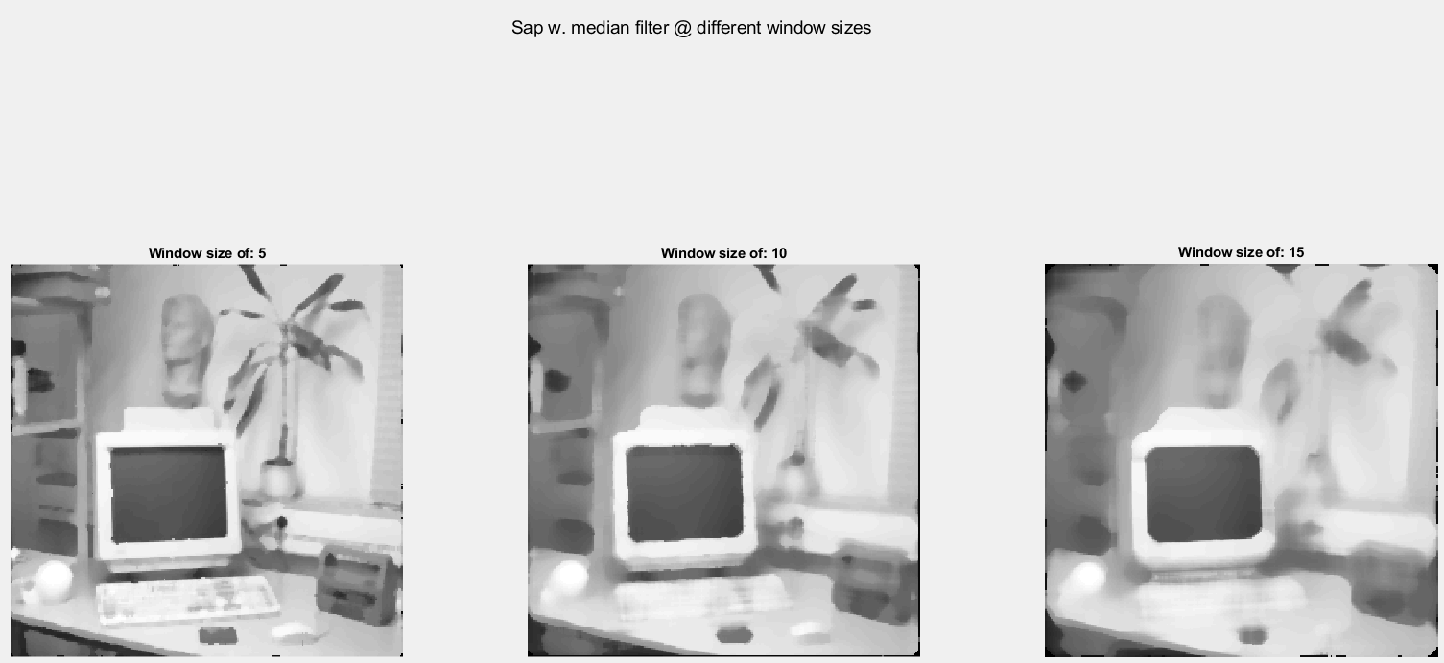

Figure - Salt and Pepper noise with Median Filter

The ideal low pass filter is easy to implement and understand but it has the inherit problem of removing all the higher frequencies which contains not only noise, but information also. The lower cut-off frequencies have a lot of ringing and blurring which improves with higher frequencies. The image, nonetheless, is not improved.

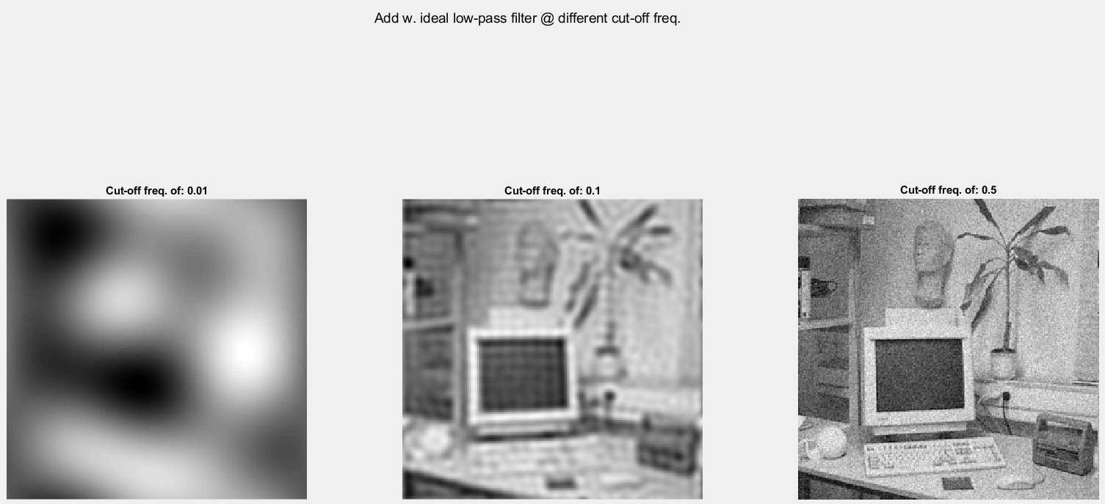

Figure - Gaussian noise with Ideal Low-Pass Filter

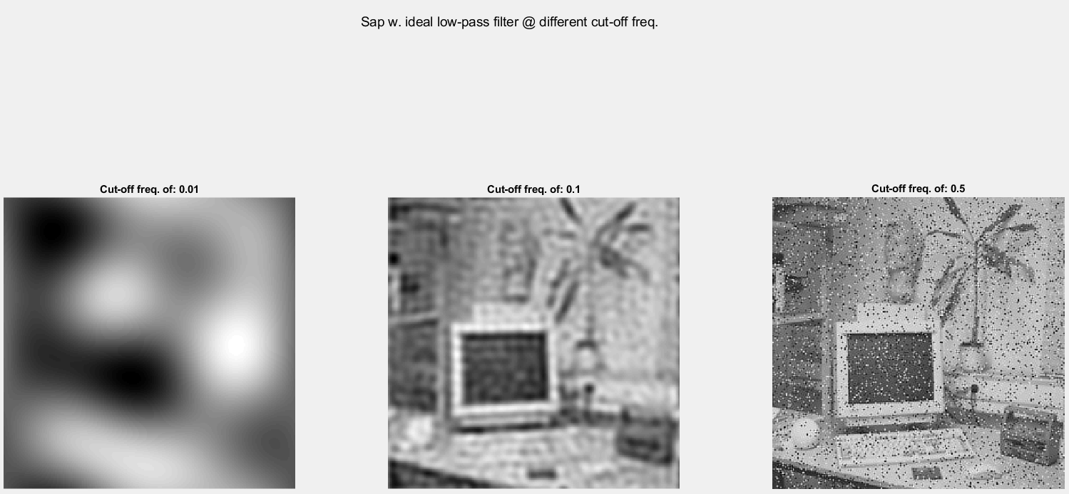

Figure - Salt and Pepper noise with Ideal Low-Pass Filter

___________________________________________________________________________

**Question 18**: What conclusions can you draw from comparing the results of the respective methods?

Answers:

What filter used should be dependent on the type of noise one is experiencing. Gaussian noise is best handled with a gaussian filter and sap noise is best handled with a non-linear median filter.

It is important to set the parameters right for the filter, regardless if it is variance, window size or cut-off frequency. An important thing I learnt is that gaussian and ideal low pass filters are linear, whilst the median filter is not.

___________________________________________________________________________

**Question 19**: What effects do you observe when subsampling the original image and the smoothed variants? Illustrate both filters with the best results found for iteration i = 4.

Answers:

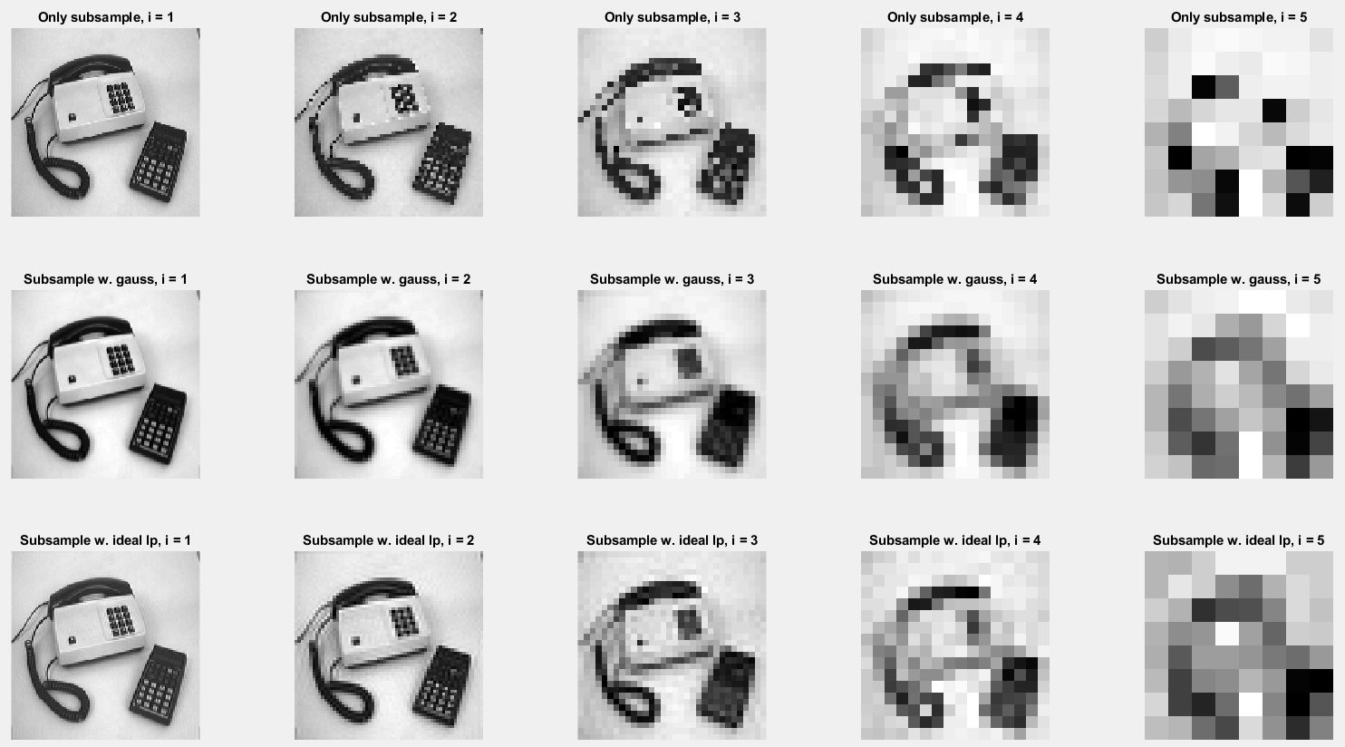

Figure - The subsampled images with index for number of iterations. The top row is only subsampled. The middle row is smoothed using Gaussian Filter and then subsampled. The bottom row is smoothed using Ideal Low-Pass Filter, then subsampled.

The ones that have been filtered are much smoother than the only subsampled version. There is some ringing in the ideal low pass filtered image, but they are both much better quality than the one that is not filtered.

In the image were i = 4, the general form of both filtered versions is intact. Whilst the unfiltered image is aliased. However, all these images are in my opinion severely distorted due to the information loss in the subsampling.

___________________________________________________________________________

**Question 20**: What conclusions can you draw regarding the effects of smoothing when combined with subsampling? Hint: think in terms of frequencies and side effects.

Answers:

Smoothing, then sampling, helps with information loss. When sampling, the sampling frequency should be above half of the maximum frequency. The so-called Nyquist theorem. By using filters, one lowers the maximum frequency and thus allows for lower sampling frequencies (which are present at subsampling).

___________________________________________________________________________